Launch one EC2 using Amazon Linux 2 image and add a script in user data to install Apache

signing in to aws console and and got ec2
Then in instance press on launch instance and select recommended steps.

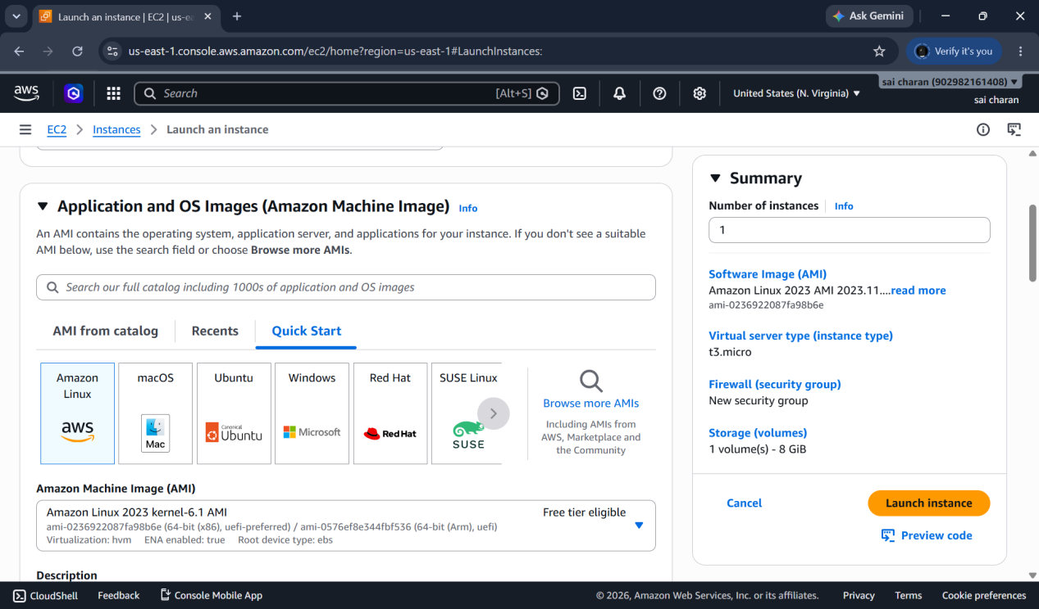

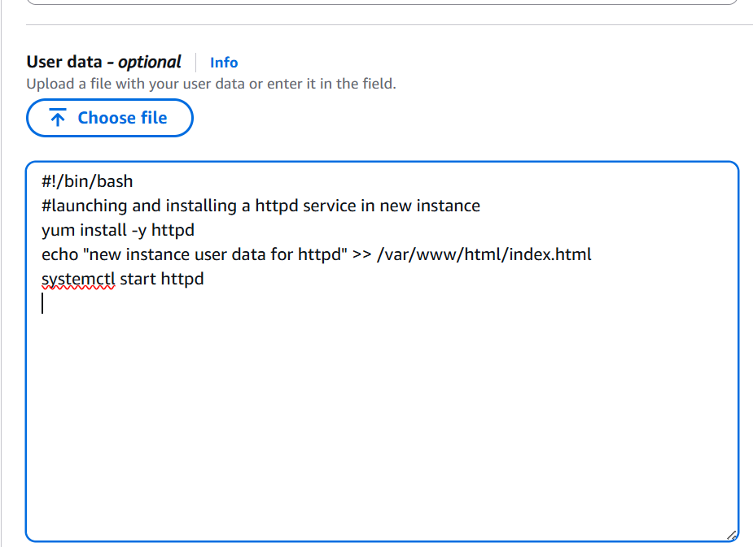

As I have already added httpd data while launching the instance now after launching the instance the httpd is active and running

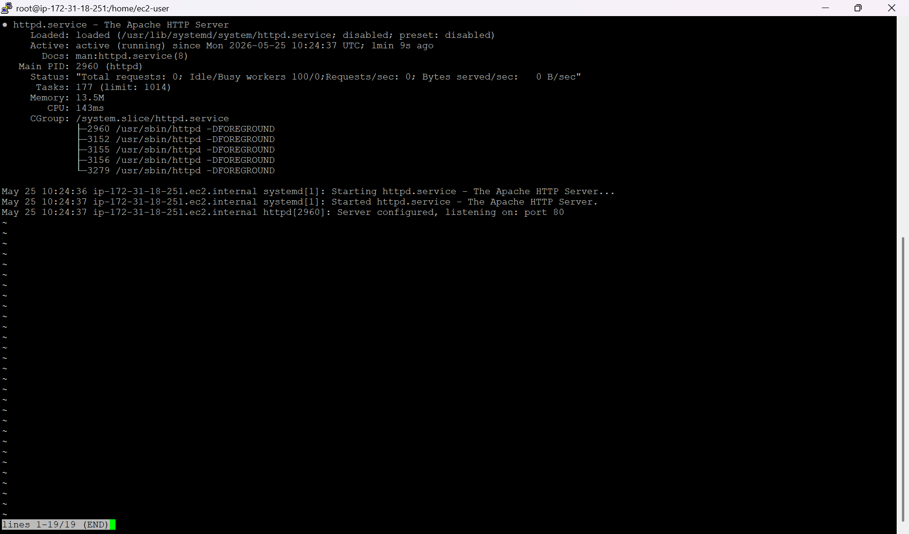
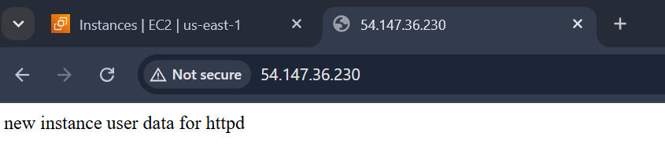

Launch one EC2 using Ubuntu image and add a script in user data to install Nginx

Launching a new instance using ubuntu image with custom requirements and adding the nginx in user data

User-data I have used

#!/bin/bash
# Update the local package
apt-get update -y
# Install Nginx
apt-get install nginx -y
# Start Nginx service
systemctl start nginx
# Enable Nginx to start on boot
systemctl enable nginx
# Optional: Create a custom landing page
echo "Welcome to Nginx on Ubuntu" > /var/www/html/index.html

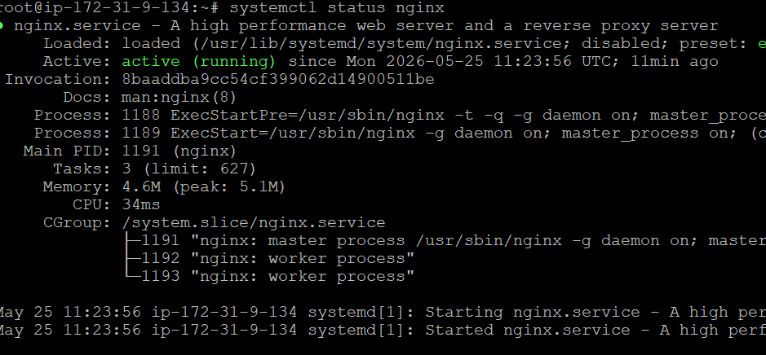
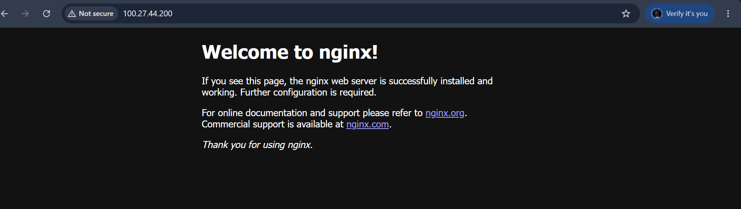

Launch one Windows server and install Tomcat on Windows

I will be launching a new instance with windows os and giving user-data for tomcat

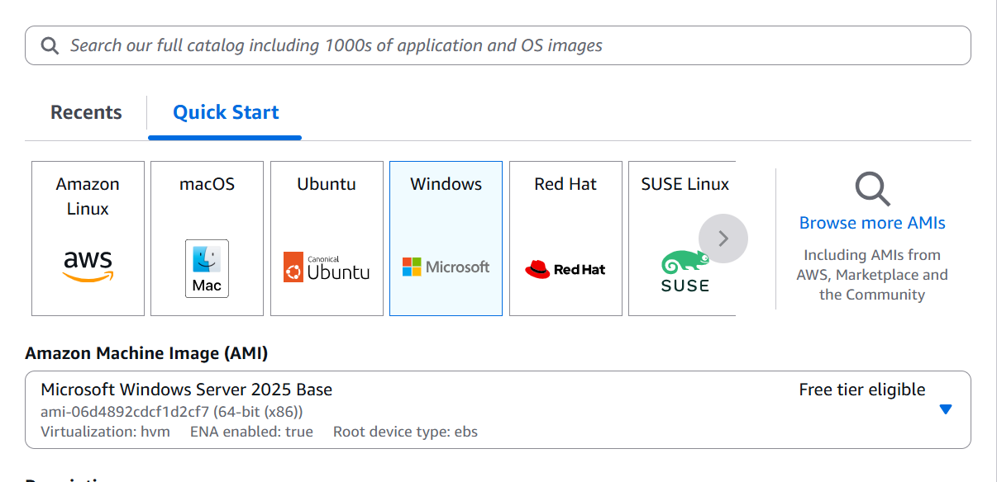

Create a Windows Server instance

Open Remote Desktop Connection
Enter the server's IP, username, and password
Enter username as Aministrator
And for password decrypt the pem file froom ec2 instance rdp connect
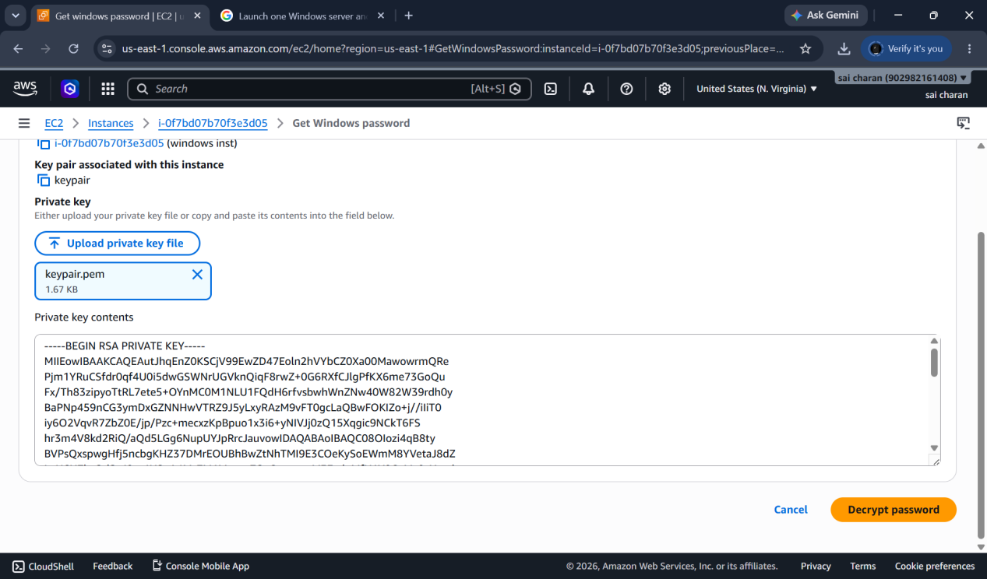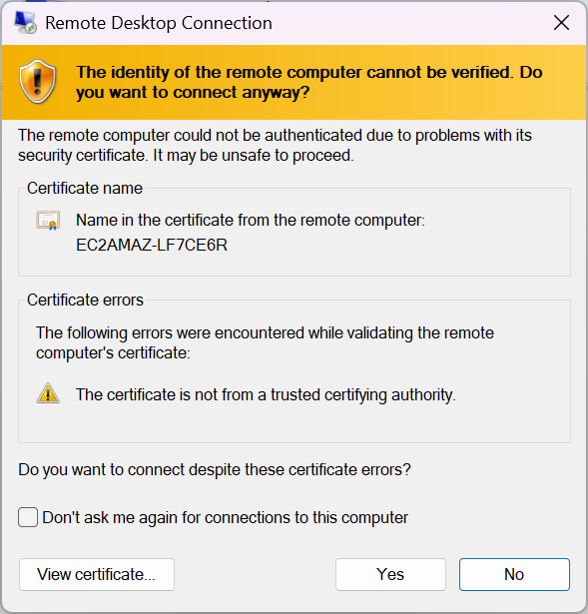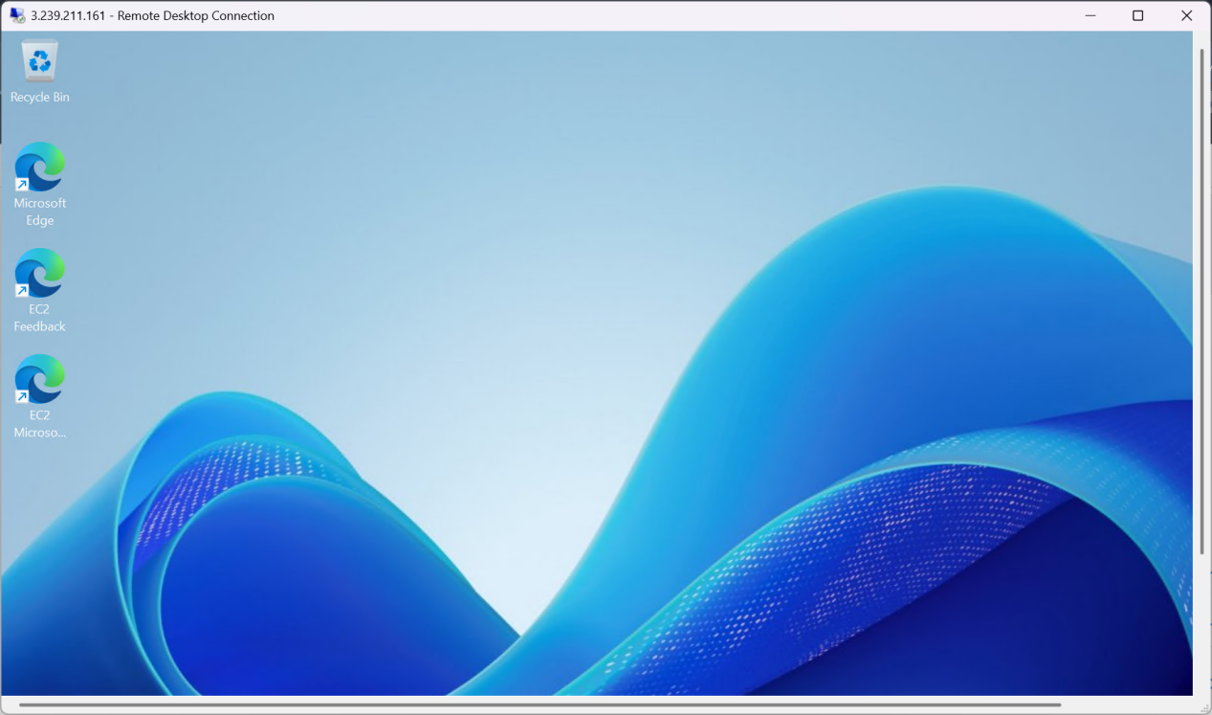

And we need to install prerequisites for tomcat that is java

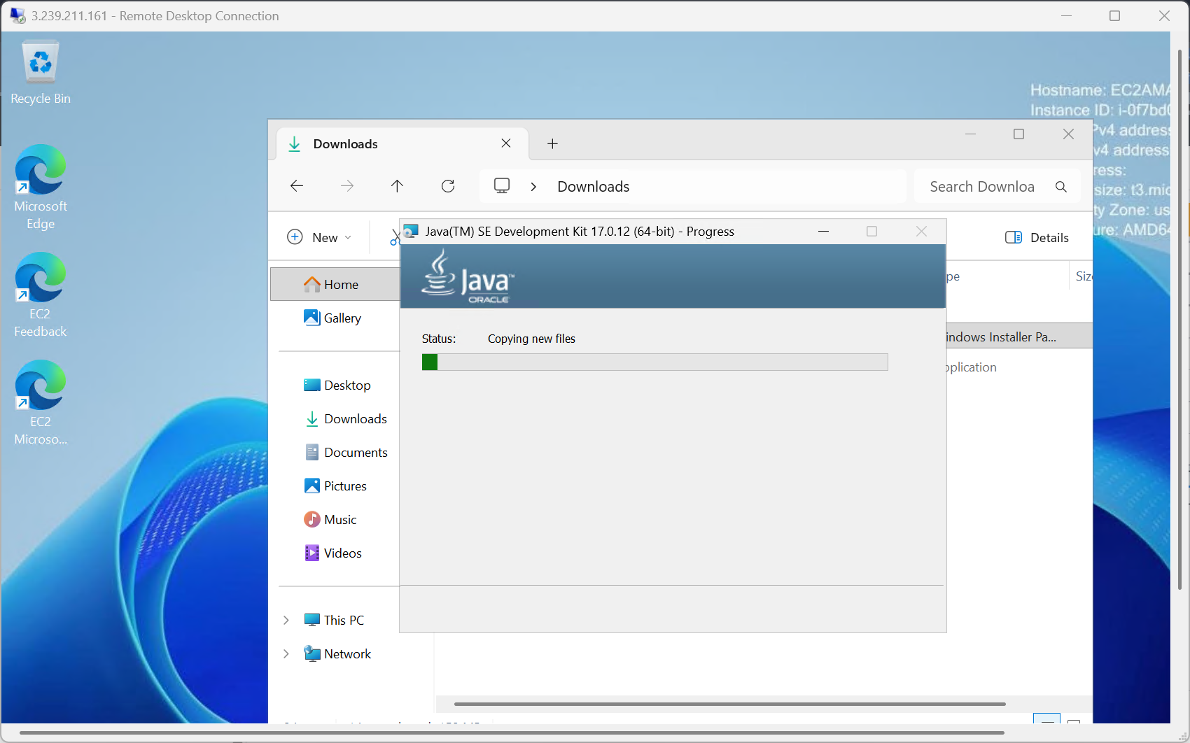

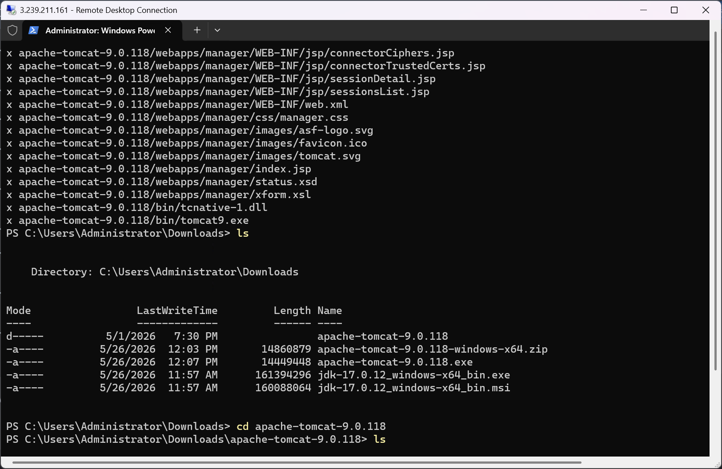

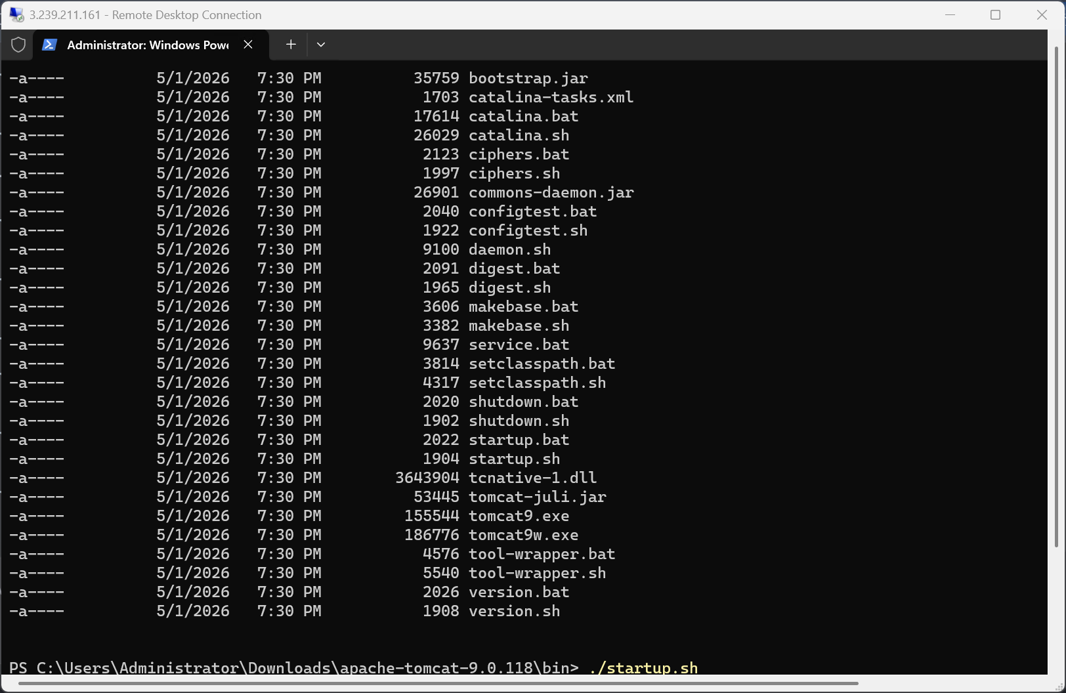

Now the tomcat has been succesfully installed and started
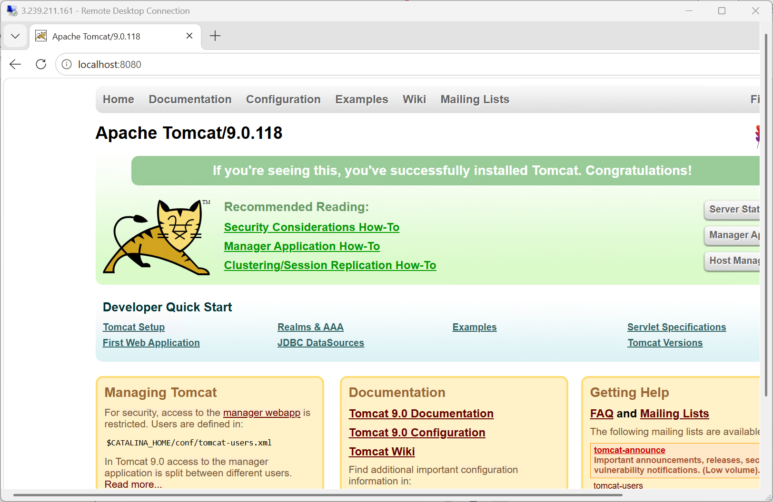

Take a snapshot of the instance created in Task 1

Creating a new image for 1 st instance and and we can use it as a backup instance for the 1st instance

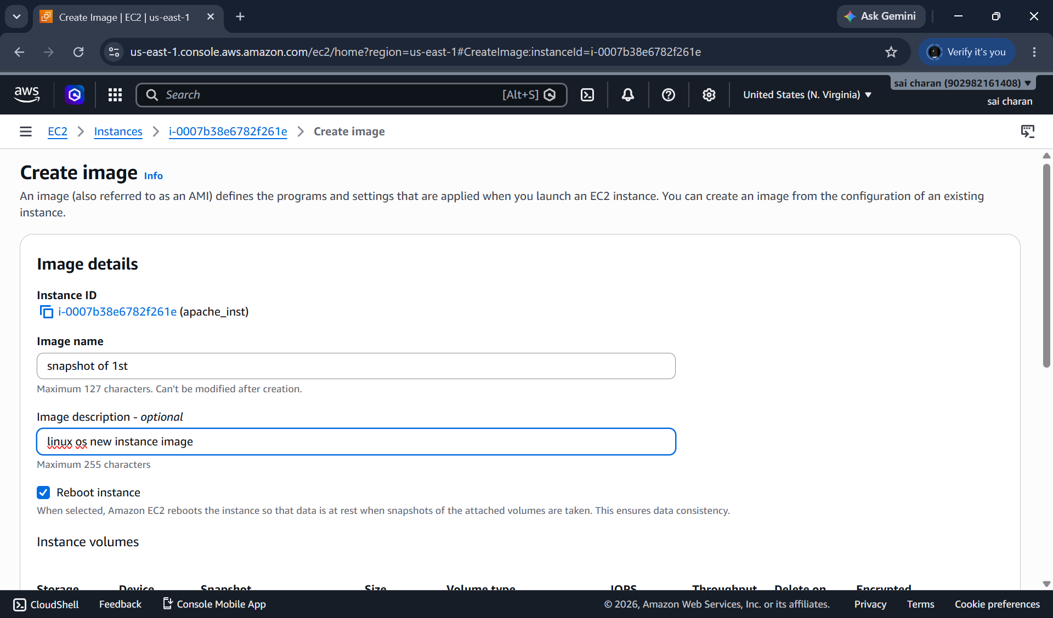

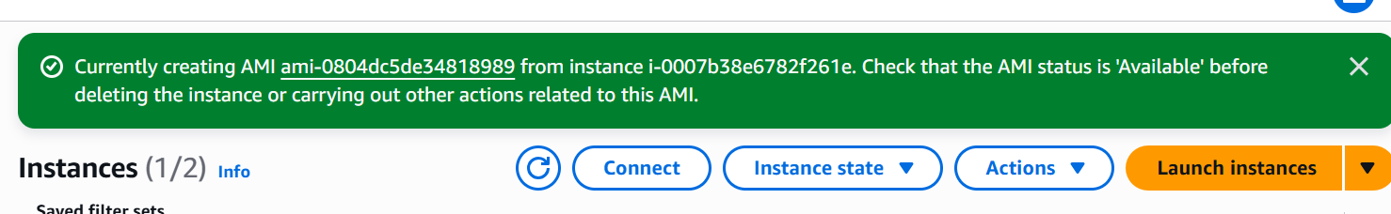

Here we can see new3 image of 1st instance has been created and we can new instance using this image or snapshot this will act as backup of 1st instance

Assign passwordless authentication for the EC2 created in Task 2

Here I will be creating a new user for ubuntu instance and providing access without password

First I will add new user in ec2 instance
Then give details of new user
Here I wont be sharing my pemkey details but I will be adding the new user ssh-keygen pub key to the .ssh/authorized_keys
Then the user wont be needing the pem key to login
Then I can enable passwordauthentication as ye/no based upon the access of user

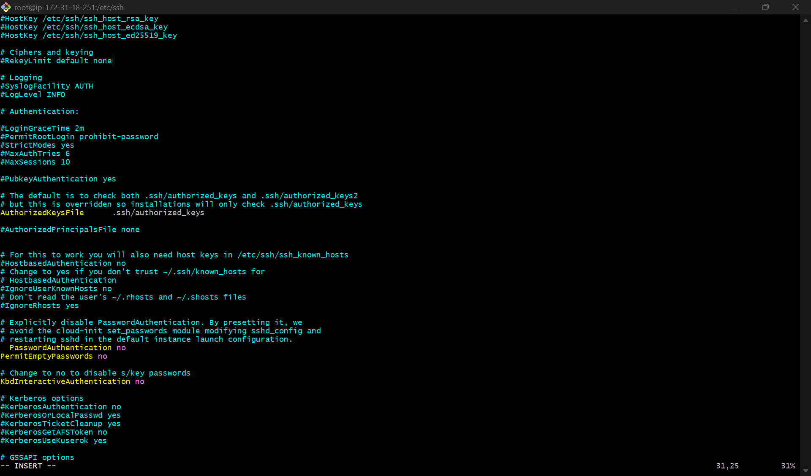

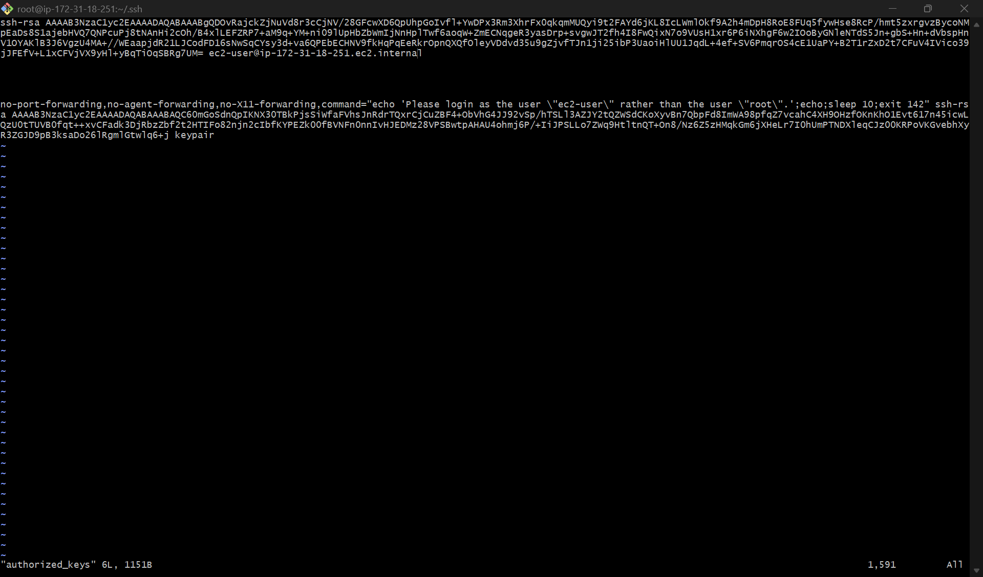

Launch any EC2 using the spot purchasing option.

Launching a new instance using amazon linux os
And got to advanced settings and on purchasing option click on spot instances
Here spot instance: we can bid for the particular instance and costs hourly if somone bids more for our instance then we will be revoked the instance access

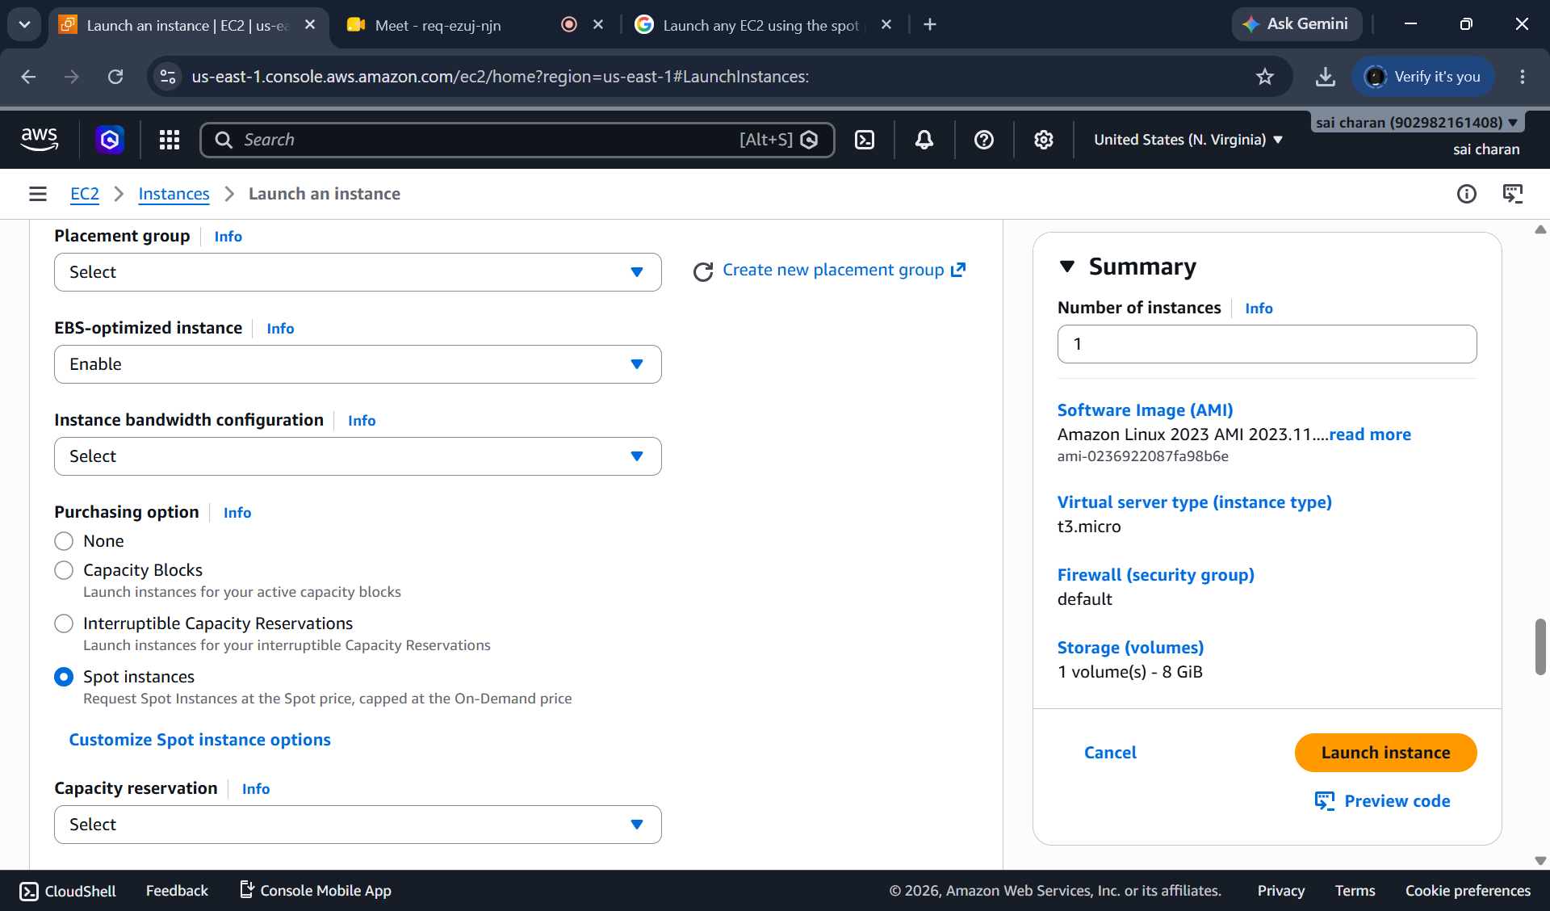

Enable termination policy on the EC2 created in Task 2

I can prevent my instance deletion by mistake I can enable termination process in actions
And click on enable
By this we can enable termination protection for instance

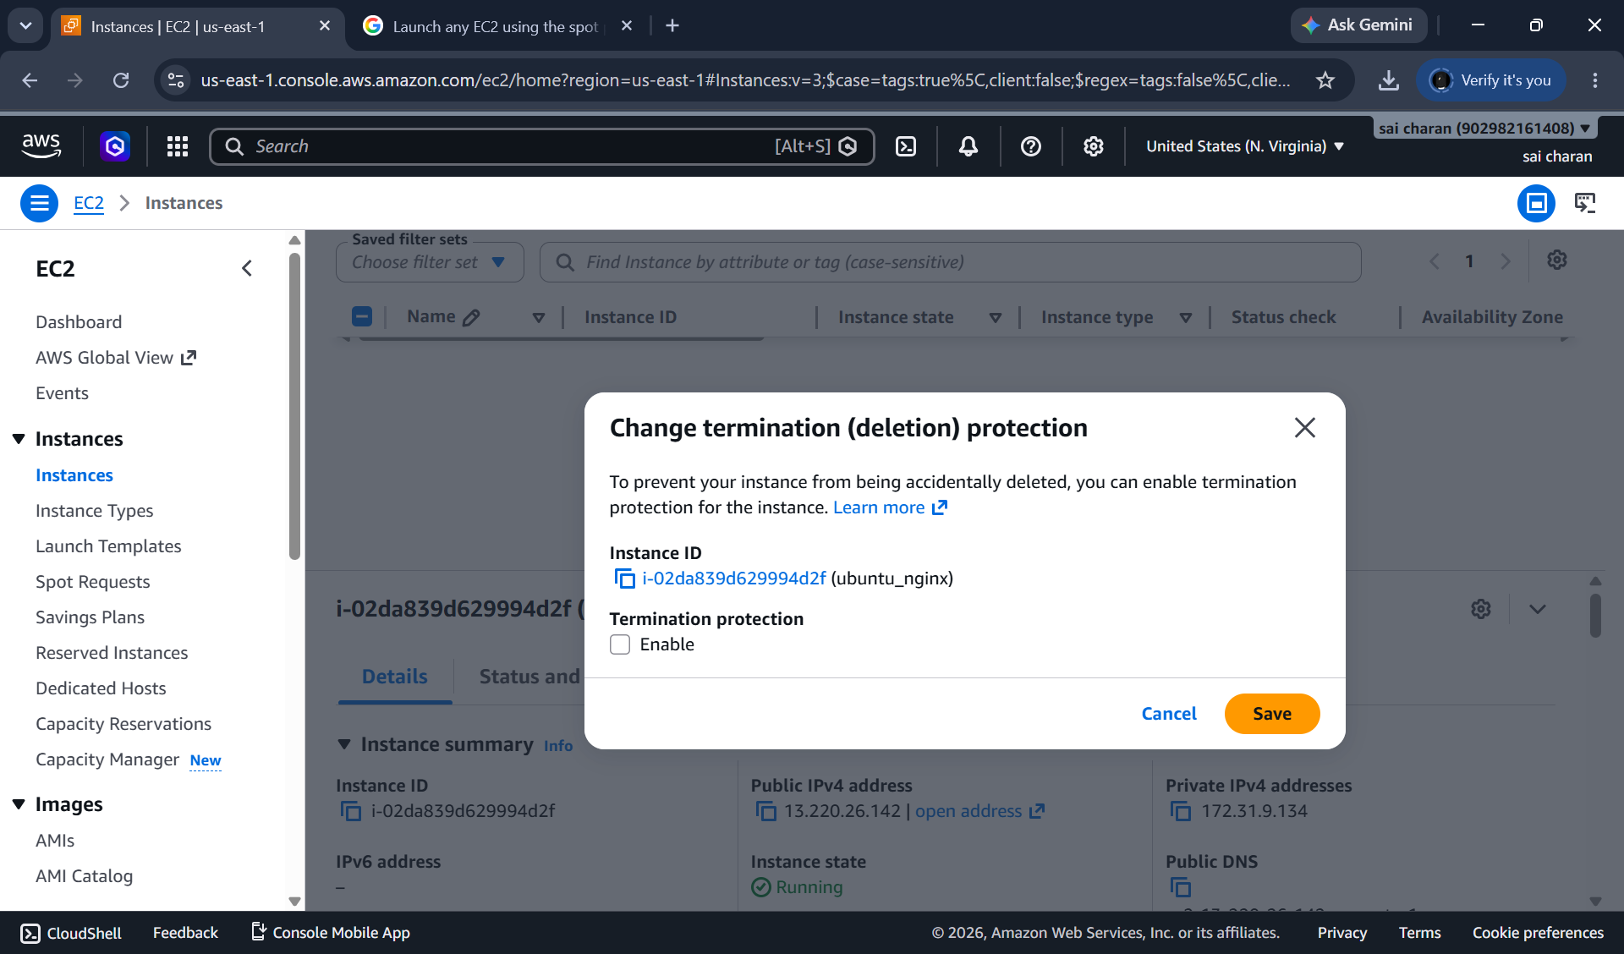

Launch one EC2 using AWS CLI

Install aws msi installer
And create a new iam user for ec2 instance
And create accesskey
In cmd type aws configure
Here it will ask for accesskey and secret key
Enter an now you can see the region
Enter specific region
Then access keys has been linked to cmd and now we can configure the ec2

